**Market Power and Innovation in the Intangible Economy (JHOX)**

**By Maarten De Ridder**

**Three macroeconomic trends**

Productivity growth has declined sharply across advanced economies since the mid-2000s. In the United States, productivity growth between 2005 and 2018 averaged less than half its long-term rate. This slowdown followed after an episode of above-average growth in the 1990s, fuelled by the rise of information and communication technologies (Fernald 2015). A similar slowdown occurred in most European countries. Indeed, productivity in France and the United Kingdom has almost flatlined for the last 15 years.

The initial surge and subsequent decline in productivity growth coincided with two other macroeconomic trends occurred: the fall of business dynamism and the rise of corporate market power and firm concentration. Business dynamism, which is the process of firms growing, shrinking, emerging, and failing, has been declining for the last 30 years. Signs that business dynamism is weakening include the decline of the rate at which workers reallocate to new employers (e.g., Decker et al. 2018) and the decline in the number of start-ups as a fraction of all firms in the economy (e.g., Calvino et al. 2016, Pugsley and Sahin 2018). Recent research on market power shows that the mark-up that firms charge over their marginal costs has increased sharply, while the share of output produced by the largest firms in a sector has risen over the same timeframe (De Loecker et al. 2018, Autor et al. 2017).

**Keynes Fund Project**

In this Keynes Fund project, I show that these trends can be explained by the rise of intangible inputs, such as information technology (IT) and software. I argue that if some firms rely more heavily on intangible inputs in their production process than others, this has a negative effect on the entry of new firms, as well as on long-term growth and innovation.

A key difference between intangible and other (tangible) inputs is that intangibles scale: they can be duplicated at close to zero marginal costs (Haskel and Westlake 2017). This means that when intangible inputs are used to produce a good, the cost structure of production changes. Firms need to invest in the development and maintenance of intangible inputs but face minimal additional costs of using these intangibles when production is scaled up. A rise in the use of intangible inputs therefore shifts the cost of production away from variable towards fixed costs. This notion is confirmed in Figure 2, which plots a new measure of fixed costs as a fraction of total costs using balance sheet and income statement data on the universe of French firms. The project furthermore shows that fixed costs are higher in service and ICT industries, and that the ratio of fixed-to-variable costs increases significantly when firms adopt large IT systems.

**Figure 2.** Fixed costs as a fraction of total costs



Data: Left figure: listed firms in the United States in Compustat, 1980-2016. Universe of non-financial French firms in FICUS-FARE, 1994-2016. Fixed costs are derived from the difference between average profit margins and marginal cost mark-ups. Details in De Ridder (2021).

**From intangible inputs to the slowdown of productivity growth**

To show how these scalable intangible inputs can drive the three macroeconomic trends, I embed them in a rich model of endogenous growth. Firms produce one or multiple products, that are added or lost through creative destruction. They invest in research and development (R&D) to produce higher quality versions of goods that other firms produce. Successful innovation then causes the innovator to become the new market leader.

Intangible inputs change the innovation process in the model, because they introduce a trade-off between quality and price. If some `IT-superstars’ are able to deploy intangible inputs with greater efficiency, they are able to reduce their marginal costs by a greater fraction, which allows them to sell at lower prices. If a firm with less intangible-adoption develops a higher quality version of a good that one of these firms sells, the incumbent could undercut the innovator on price. They therefore become `untouchable’, and are able to hold on to market leadership. The presence of firms with a high take-up of intangible inputs, therefore, deters other firms and entrants from innovating and developing higher quality products. They also reduce the effect of research and development activities on growth, making ideas `harder to find’ (Bloom et al. 2017).

Table 1 summarizes these long-term effects quantitatively. The model is calibrated using data on American and French firms, and shows that the rise of high-intangible firms is able to explain a significant fraction of the slowdown of productivity growth for both countries.

Note that despite these long-term effects, the initial effect of the rise of high-intangible firms is positive. Firms with high intangibles `disrupt’ sectors across the economy by investing more in research and development, which causes economic activity to concentrate disproportionately around these firms. As the economy transitions to the new balanced growth path, there is an initial increase in productivity, as firms deploy more intangible inputs. This comes with an increase in mark-ups because market leaders have a larger cost-advantage over their competitors, although the increase in fixed costs implies that mark-ups overstate profitability. Mark-ups also offset the effect of the decline in marginal costs on prices, which could explain why the last decade has been simultaneously characterized by rising mark-ups and low inflation.

**Table 1:** Comparison of steady states before and after the rise of intangibles

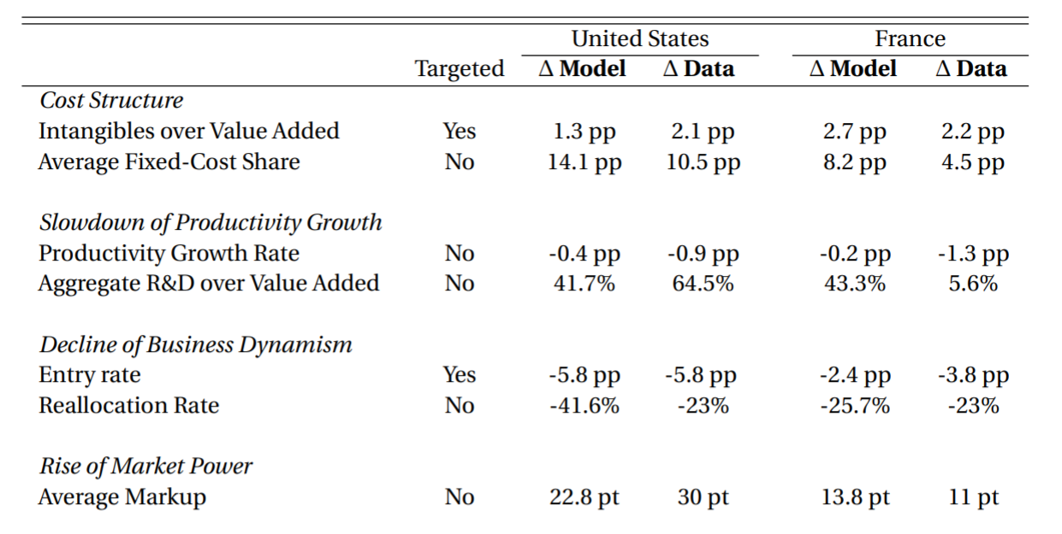

**Discussion**

The welfare effects of the rise of intangible inputs in the model are negative. That is despite the fact that high-intangible firms are more productive and innovative than their competitors. The negative effects arise because these firms impose a negative externality on other firms. This Keynes Fund project has therefore identified a new source of market failure in innovation.

In the working paper that summarizes the output of this Keynes Fund project (De Ridder, 2021), I quantify the associated welfare costs, as well as potential policy interventions. The overall message is that advances in intangibles and information technology have the potential to be welfare enhancing, but only if they are sufficiently *inclusive.* Any policy that fosters diffusion of such technologies therefore have the potential to deliver significant welfare gains.

**Impact and Outputs**

**The project has led to a Cambridge INET/Janeway Institute working paper.**

**The project was discussed in speeches by the following high-level policy makers:**

* **The Vice President of the European Central Bank:**

<https://www.ecb.europa.eu/press/key/date/2019/html/ecb.sp190924_1~11f3b9886d.en.html>

* **A member of the Monetary Policy Committee (MPC) at the Bank of England:** <https://www.bankofengland.co.uk/-/media/boe/files/speech/2020/monetary-policy-in-the-intangible-economy.pdf?la=en&hash=355DD0667ABC60E2BDEE465E05448E863D57CE54>
* **Dutch Minister of Finance:**

<https://www.rijksoverheid.nl/documenten/kamerstukken/2020/09/07/nationaal-groeifonds>

**The project was presented at policy seminars in the following departments:**

* **Chicago Federal Reserve, Dallas Federal Reserve, European Central Bank, Bank of England, G20/OECD Global Forum on Productivity, Richmond Fed,** 7th Joint CBRT/ECB.

**The project was presented at the following academic seminars:**

* Berkeley, Berkeley Haas, BI, Bocconi, Boston University, Brown, CAED, Cambridge, CREi, EIEF, IIES, Kent, LSE, Manchester, Maryland, Nottingham, SSE, Tinbergen, UCLA, UCSD, UPF, USC, VMACS, Wharton, Yale, Zurich.

**The project has received the following rewards:**

* **Best Paper at the 2019 European Commission/OECD Innovation Survey Concordi 2019**

* **Best Job Market Paper in Macroeconomics, Unicredit Foundation**

**References**

Aghion, P, A. Bergeaud, T. Boppart, P. Klenow, and H. Li, “A Theory of Falling Growth and Rising Rents,” *Mimeo*. March 2019

Akcigit, U. and S. T. Ates, “Ten Facts on Declining Business Dynamism and Lessons from Endogenous Growth Theory,” *University of Chicago Mimeo.* April 2019

Autor, D H, D Dorn, L Katz, C Patterson, and J Van Reenen (2017), "The Fall of the Labor Share and the Rise of Star Firms", NBER working paper 23396. September 2017

Bloom, N, C. I. Jones, J. Van Reenen, and M. Webb, “Are Ideas Getting Harder to Find?,” *NBER Working Paper 23782.* September 2017

Calvino, F., C. Criscuolo and C. Menon (2016), "No Country for Young Firms? Start-up Dynamics and National Policies", *OECD Science, Technology and Industry Policy Papers*, No. 29. April 2016

De Loecker, J., Eeckhout, J., and Unger, G. (2018). “The Rise of Market Power and the Macroeconomic Implications”. *Working Paper,* November 2018

De Ridder, Maarten (2021), [“Market Power and Innovation in the Intangible Economy”, *Centre for Macroeconomics Working Paper 2019-07*](http://www.centreformacroeconomics.ac.uk/Discussion-Papers/2019/CFMDP2019-07-Paper.pdf)*.* November 2021

Decker, R. A., Haltiwanger, J. C., Jarmin, R. S., & Miranda, J. (2018). “Changing business dynamism and productivity: Shocks vs. responsiveness”, *NBER Working paper 24236*. January 2018

Fernald, J. (2015). “Productivity and potential output before, during, and after the great recession.” *NBER Macroeconomics Annual, Volume 29, NBER*. April 2015

Haskel, J. and Westlake, S. (2017). Capitalism without capital: the rise of the intangible economy. *Princeton University Press*

Liu, E, A. Mian, and A. Sufi, “Low Interest Rates, Market Power, and Productivity Growth*,” Becker Friedman Institute Working Papers Series 2019-09*, January 2019

Pugsley, B. W., & Șahin, A. (2018). Grown-up business cycles. *The Review of Financial Studies*, *32*(3), 1102-1147. June 2018